Hotel Bookings Analysis Project

# **Business Problem**

In recent years, City Hotel and Resort Hotel have seen high cancellation rates. Each hotel is now dealing with a number of issues as a result, including fewer revenues and less than ideal hotel room use. Consequently, lowering cancellation rates is both hotels' primary goal in order to increase their efficiency in generating revenue, and for us to offer thorough business advice to address this problem.  
The analysis of hotel booking cancellations as well as other factors that have no bearing on their business and yearly revenue generation are the main topics of this report.



## **Assumptions**

* No unusual occurrences between 2015 and 2017 will have a substantial impact on the data used.
* The information is still current and can be used to analyze a hotel's possible plans in an efficient manner.
* There are no unanticipated negatives to the hotel employing any advised technique.
* The hotels are not currently using any of the suggested solutions.
* The biggest factor affecting the effectiveness of earning income is booking cancellations.
* Cancellations result in vacant rooms for the booked length of time.
* Clients make hotel reservations the same year they make cancellations

# Research Question

* What are the variables that affect hotel reservation cancellations?
* How can we make hotel reservations cancellations better?
* How will hotels be assisted in making pricing and promotional decisions?

## Hypothesis

* More cancellations occur when prices are higher.
* When there is a longer waiting list, customers tend to cancel more frequently.
* The majority of clients are coming from offline travel agents to make their reservations.

**Analysis and Findings**

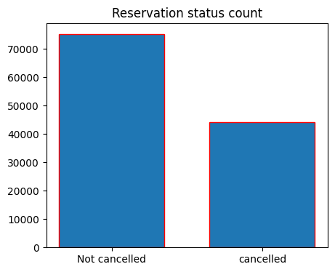

This bar graph shows the percentage of reservations cancelled and not cancelled.37% reservations were cancelled which has significant impact on hotel’s earnings. Most of the reservations were not cancelled.

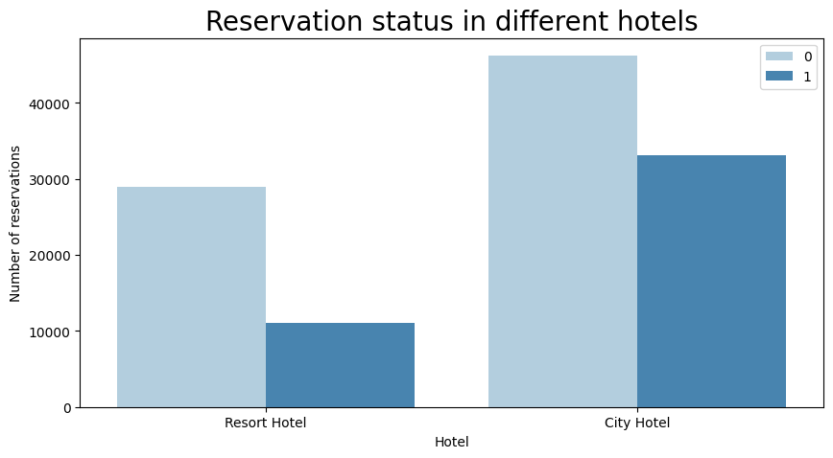

This graph shows the count of reservations done (0) and cancelled (1) in both hotels .In comparison to resort hotels,city hotels have more bookings .It is possibly said that resort hotels are expensive.

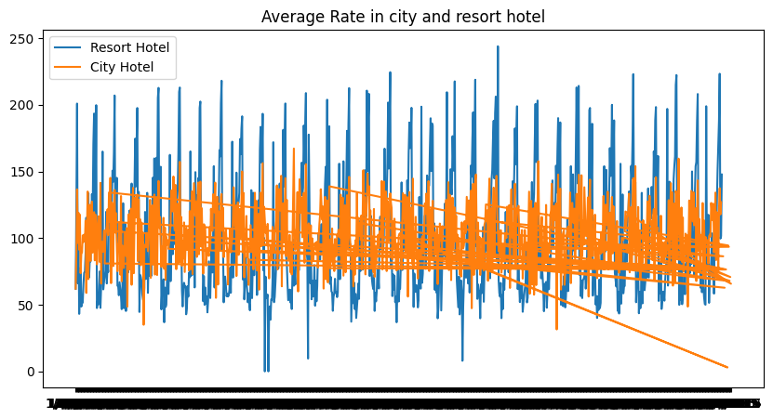

Here In this Line graph ADR value is high for Resort and low for city hotels.

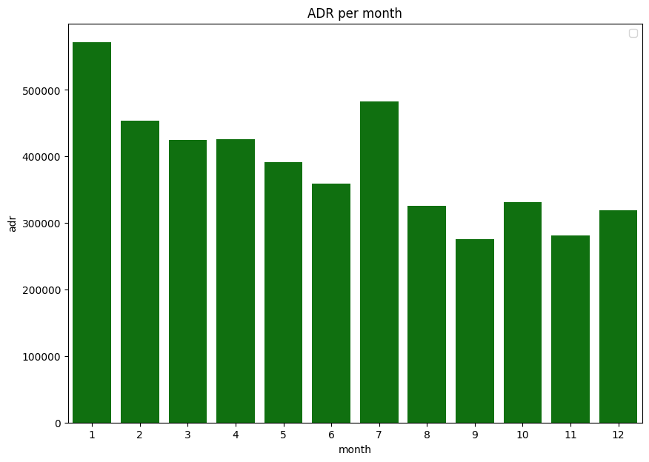

This graph shows that higher the ADR higher is cancellation. In January and August we can see ADR value is high so cancellation was high.

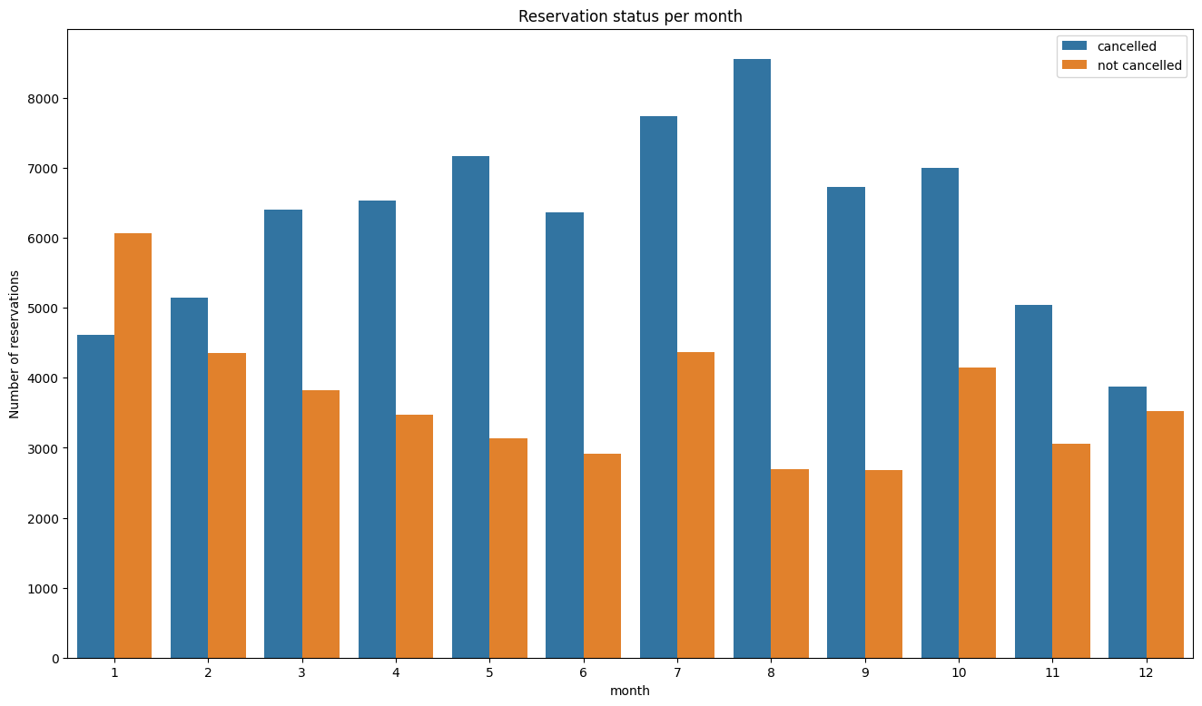

This Grouped bar graph shows count of Reservations cancelled and not cancelled in every month. The number of cancelled reservations are highest in August and highest number of not cancelled reservations are in January month.

**These are the 10 countries from where the cancellations were highest. Portugal is highest with 70% cancellation**.

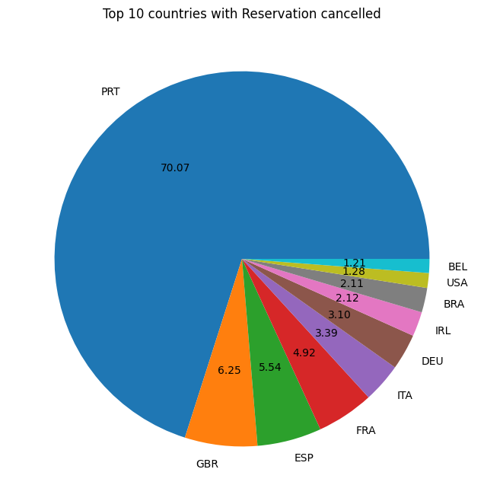Let’s check the area from where the guests are come to hotel and making reservations.Are they booking online or offline travel agencies ? Around 46% clients from online travel agencies and 27% come from groups and around 4% directly come hotel for reservations

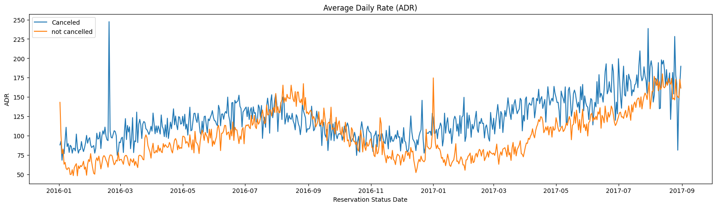 This Line Graph shows that higher the average daily rate value, cancellation is high and vice-versa. Hence proven that high prices of hotels leads to higher cancellation.

**Suggestions**

1. Cancellation rates rise as the price does. In order to prevent cancellations of reservations, hotels could work on their pricing strategies and try to lower the rates for specific hotels based on locations. They can also provide some discounts to the consumers.
2. As the ratio of the cancellation and not cancellation of the resort hotel is higher in the resort hotel than the city hotels, the hotels should provide a reasonable discount on the room prices on weekends or on holidays.
3. In the month of January, hotels can start campaigns or marketing with a reasonable amount to increase their revenue as the cancellation is the highest in this month.
4. They can also increase the quality of their hotels and their services mainly in Portugal to reduce the cancellation rate.